DOKUMENTASI PIKET JAGA KELURAHAN KESATRIAN
BULAN AGUSTUS 2025

NO. | PETUGAS PIKET | TANGGAL | FOTO | KET
1. | - ALIF SENO GUNTORO  - IRIYANTO  - AHMAD ZAINI | JUM’AT  01-08-2025 | 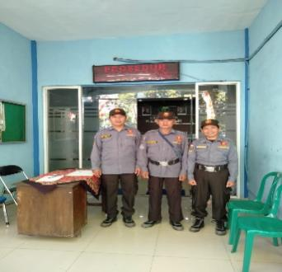
 | 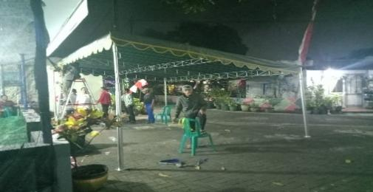 | 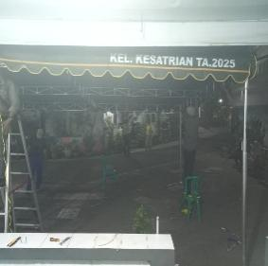 | 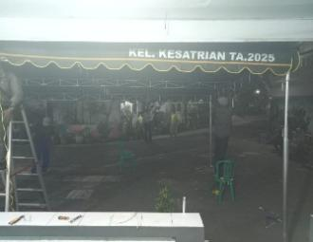
2. | - SIGIT RAHARJO  - DJOKO NUGROHO  - YOFI ANDRIANI | SENIN  05-08-2025 | 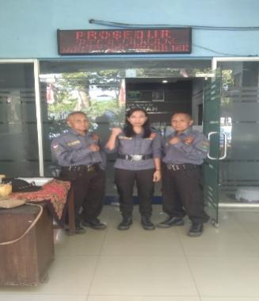
3. | - SUTIKNO HANDOYO  - ANDIK SETIAWAN  - ELIK SUKARJONO | SELASA  06-08-2025 | 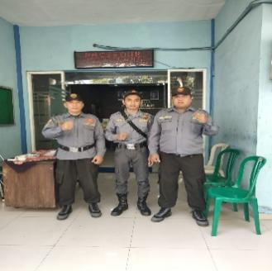
 |  |  | 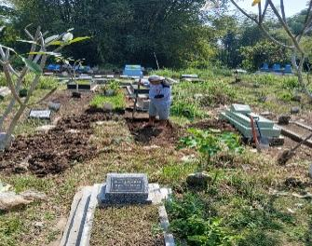
4. | - M. TAUFIK  - ABDUL SYUKUR ARIF  - FEBRI ANITA  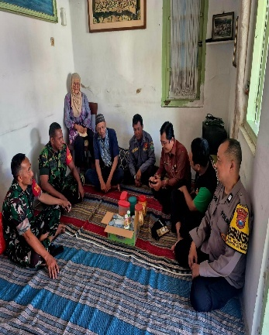 | RABU  07-08-2025 | 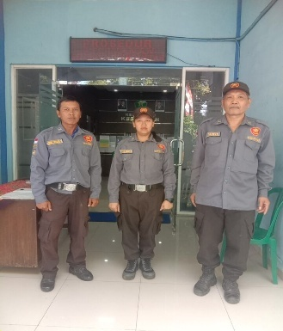
5. | - KARTANU  - ABDUL MUNI  - YULIADI | KAMIS  08-08-2025 | 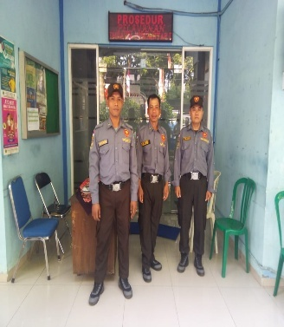
 | 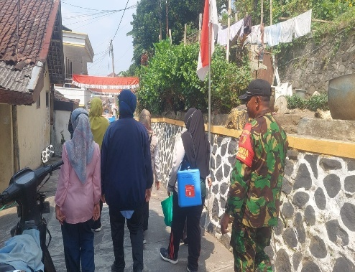 | 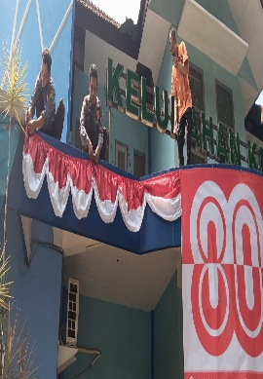 | 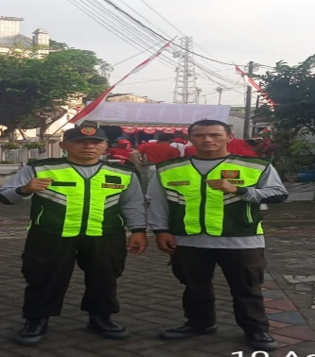
6. | - ADITIYA M P  - M FITRIA AGUSTIN | SENIN  11-08-2025 | 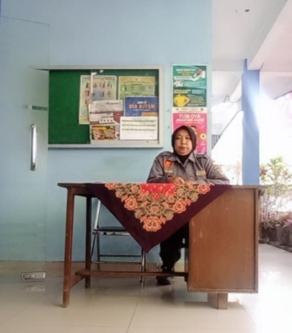
 | 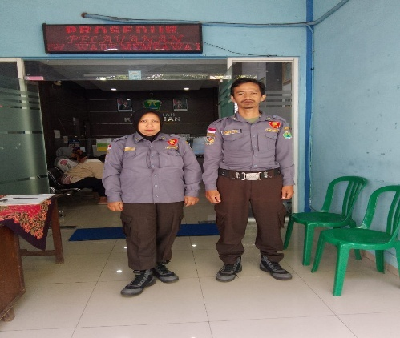 | 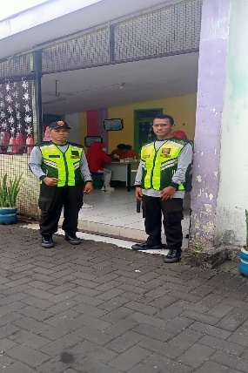 | 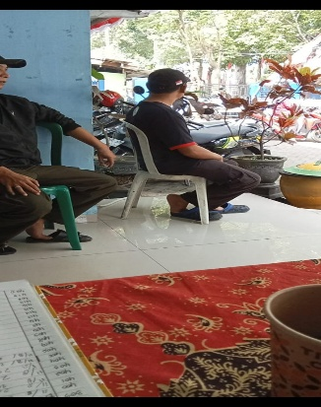
7. | - FIFIN YUNIARTA P  - SRI MUDJIANAH  - ANDIK AFIANTO | SELASA  12-08-2025 | 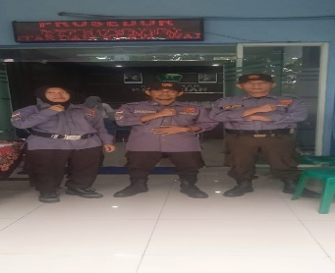
 |  |  | 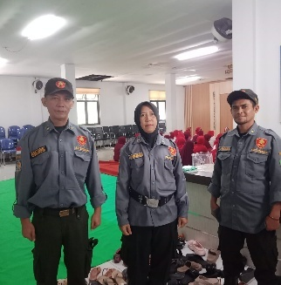
9. | - LINA YARWIYANTI  - AGUS SUSANTO  - MUSTAKIM HUDA | RABU  13-08-2025 | 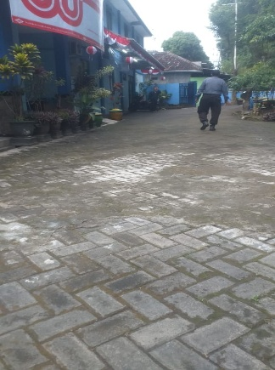
 |  | 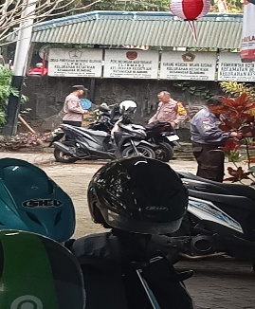 | 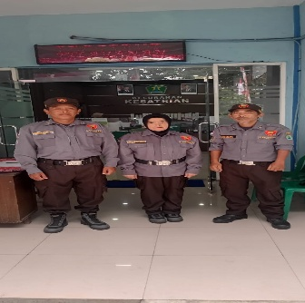
10. | - MARUDUR  - SUKATI  - TEGUH SETIAWAN | KAMIS  14-08-2025 | 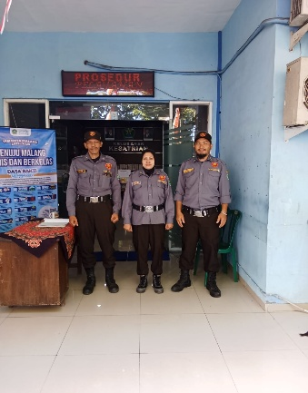
 | 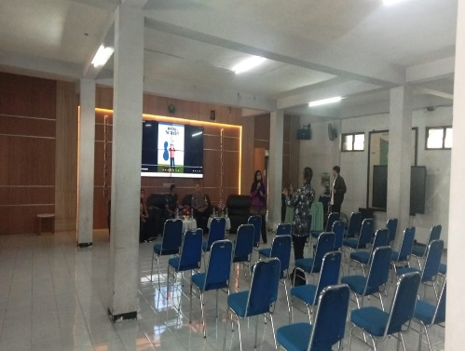 | 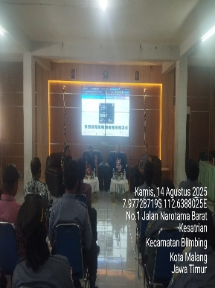 | 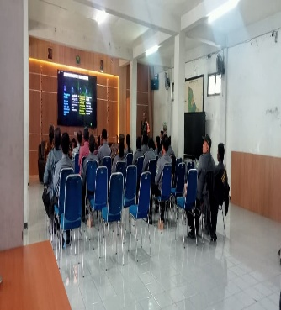
 |  | 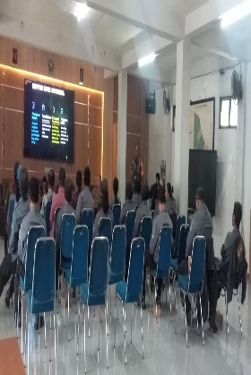 | 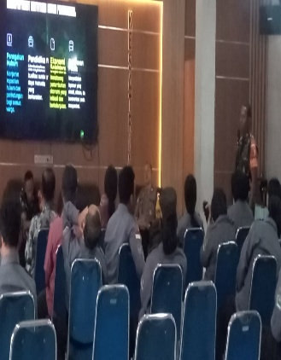
11. | - ANTON ALEXANDI  - MASYUDI  - AMIR YUSUF | JUM’AT  15-08-2025 | 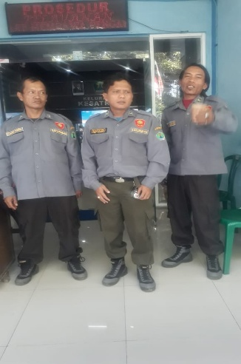
 | 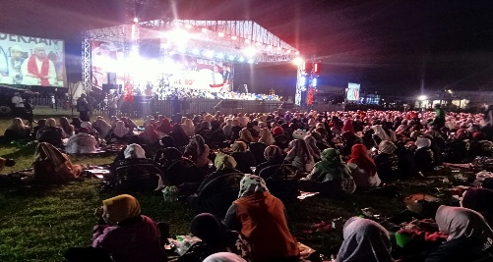 | 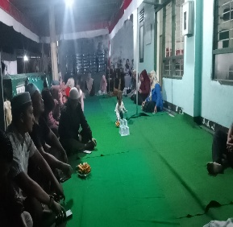 | 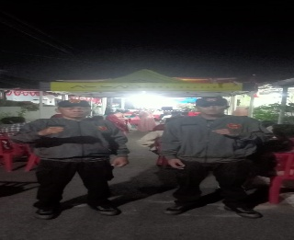
12. | - SEGER WIBISONO  - SAMSUL  - SRI WAHYUNI | SELASA  19-08-2025 | 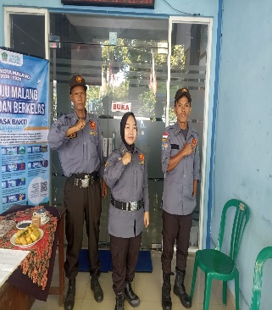
 |  |  | 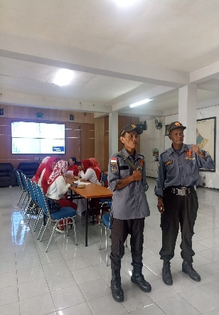
13. | - NGATEMAN  - BADRIATUS SOLIHAH  - DJANWAR H | RABU  20-08-2025 | 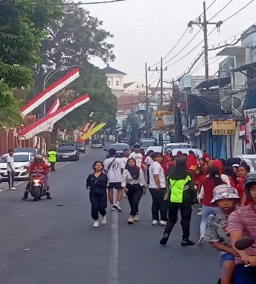
 |  | 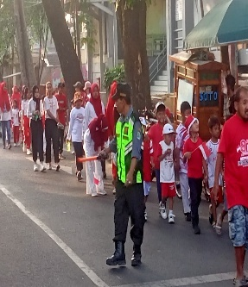 | 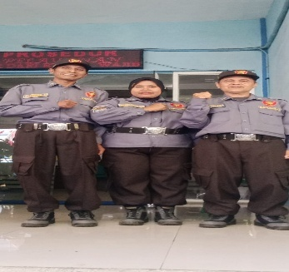
 |  | 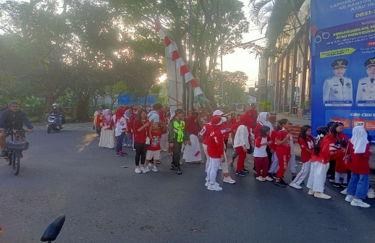 | 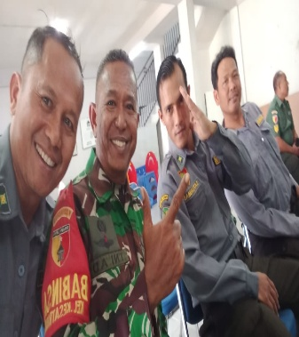
14. | - YUDI GUNAWAN  - HUGO RESTU  - YUDHA SANJAYA | KAMIS  21-08-2025 | 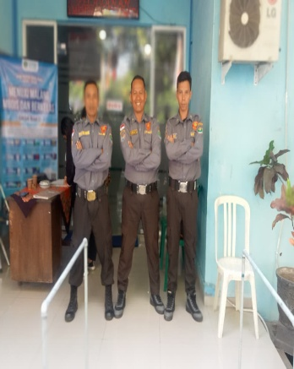
 |  |  | 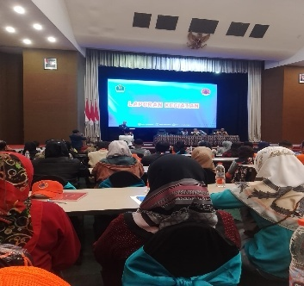
15. | - SUMANTRI  - CHUSNUL C  - ZAINUL ARIFIN | JUM’AT  22-08-2025 | 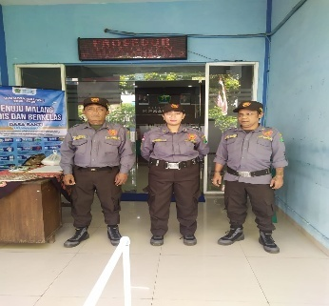
 | 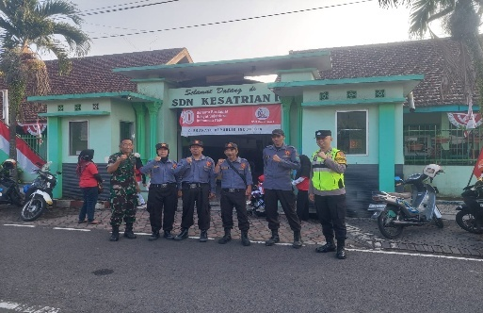 | 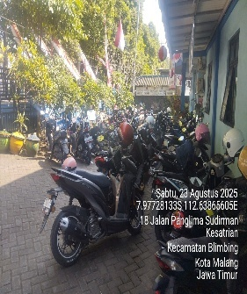 | 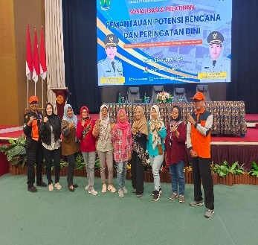
 | 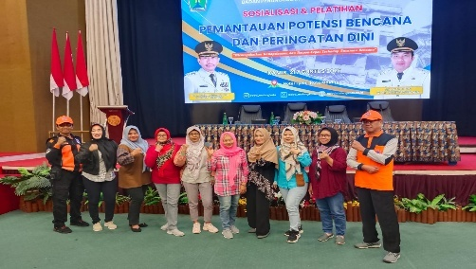 | 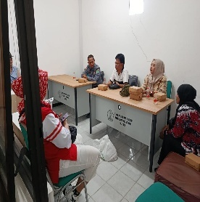 | 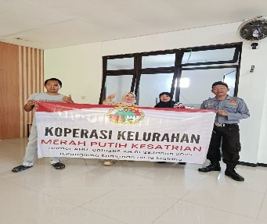
 | 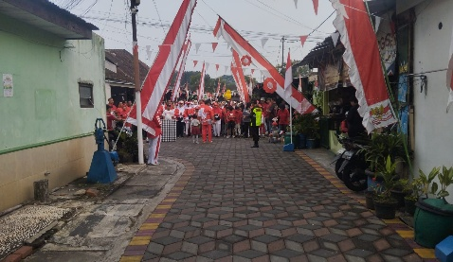  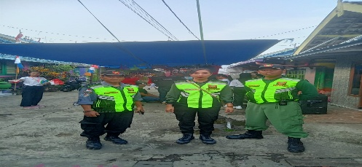 | 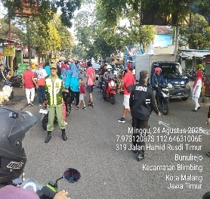  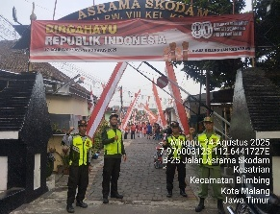 | 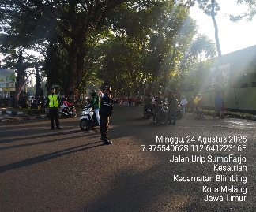  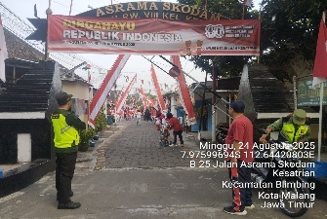
 | 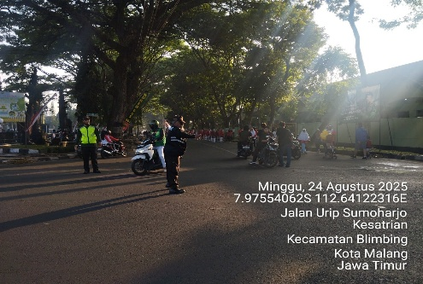 | 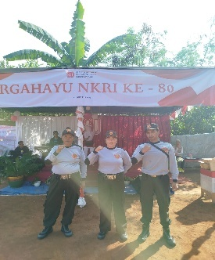 | 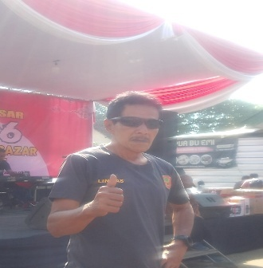
16. | - TYAS RENA T  - MURSID  - CHOLILAH | SENIN  25-08-2025 | 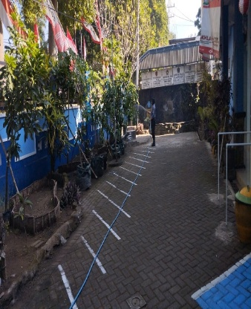
 |  |  | 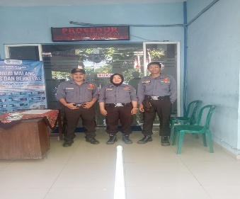
17. | - FAISOL AKBAR  - SURADJI  - M. YUSSAK | SELASA  26-08-2025 | 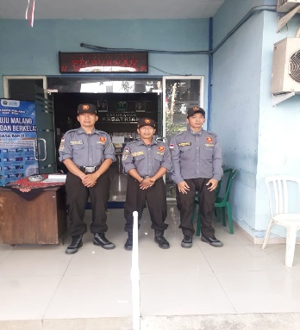
 |  |  | 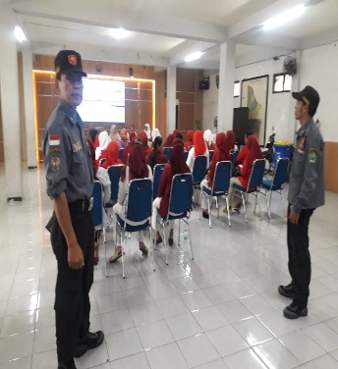
18. | - ADITIYA M P  - SATRIYO WIBOWO  - AGUS APIT S | RABU  27-08-2025 | 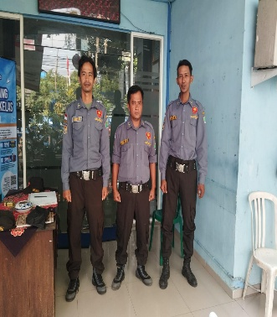
19. | - ARIEF SUHARTONO  - SUNARMI  - CHUSNUL H | KAMIS  28-08-2025 | 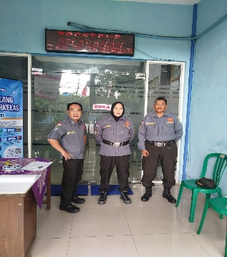
 | 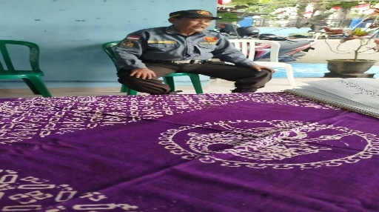 | 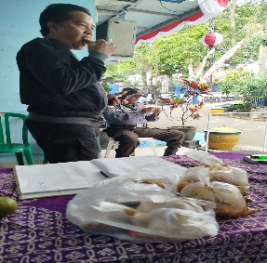 | 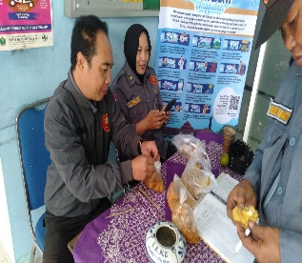
20. | - ARI WIBOWO  - M. TAUFIK  - ELIK SUKARJONO | JUM’AT  29-08-2025 | 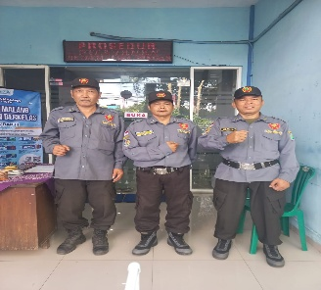
 | 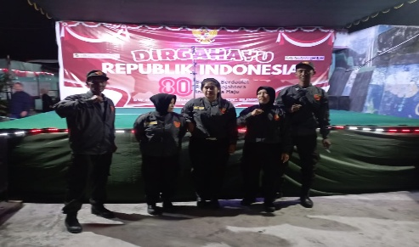 | 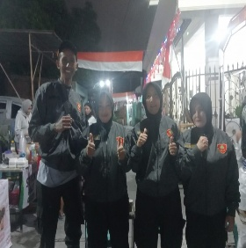 | 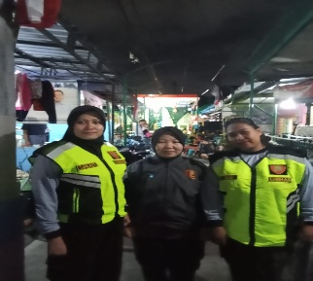
 | 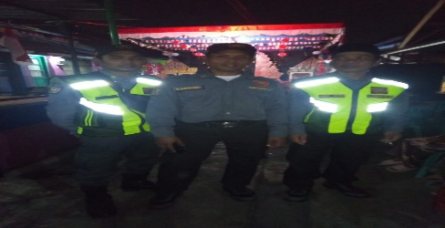 | 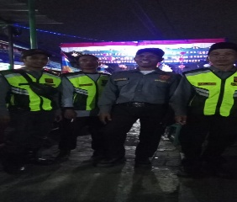 | 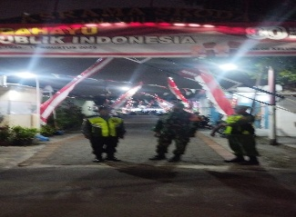
 | 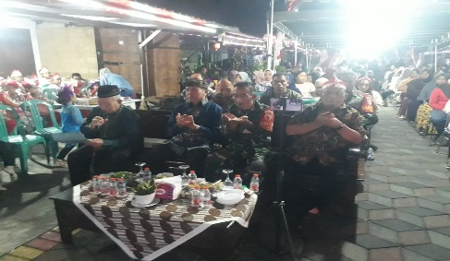 | 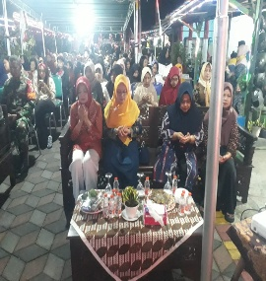 | 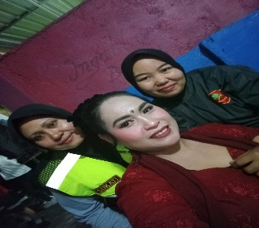
 | 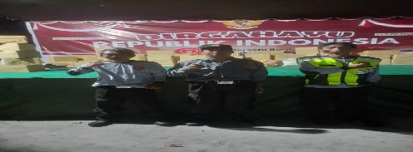  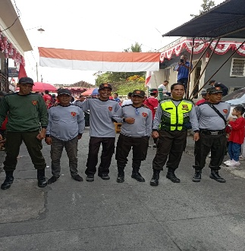  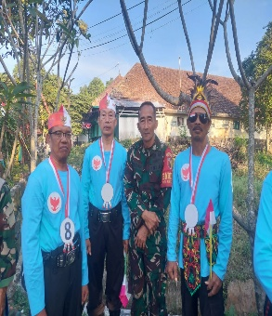 | 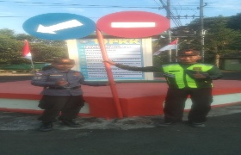 | 