KEGIATAN PENYALURAN BANTUAN LANGSUNG TUNAI ( BLT ) CUKAI

BAGI MASYARAKAT KELURAHAN ARJOSARI

Selasa, 5 Desember 2023

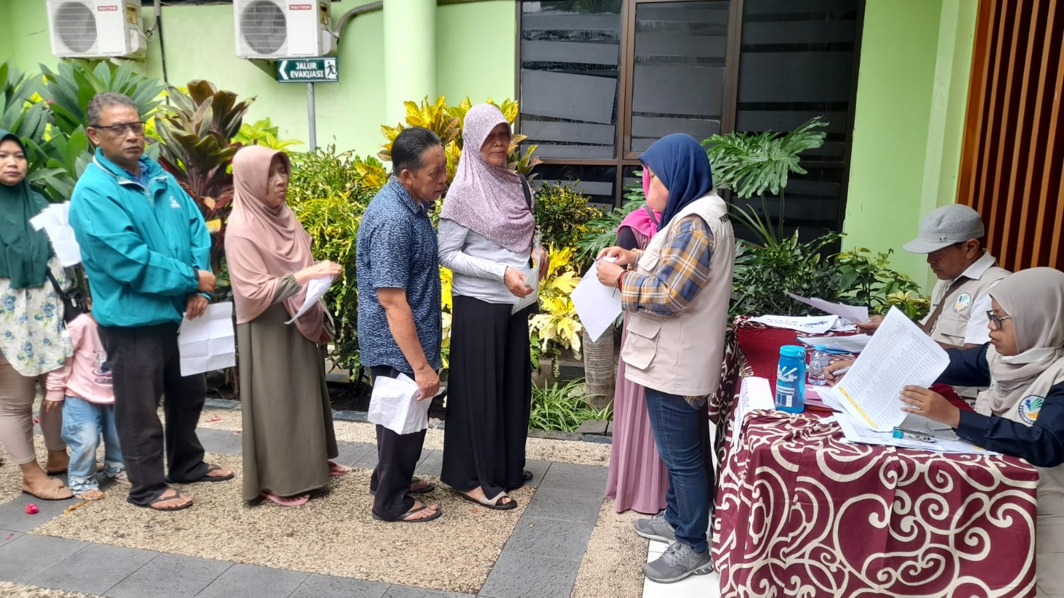

JUMLAH PENERIMA BANTUAN LANGSUNG TUNAI ( BLT ) CUKAI

BAGI MASYARAKAT KELURAHAN ARJOSARI

Selasa, 5 Desember 2023

|  |  |  |  |
| --- | --- | --- | --- |
| NO. | BULAN | JUMLAH WARGA YANG MENERIMA BANTUAN | KETERANGAN |
| 1. | DESEMBER | 194 Orang | Diambil tepat waktu |