DOKUMENTASI KEGIATAN PIKET ANGGOTA LINMAS KESATRIAN
BULAN MARET 2024

KEGIATAN PIKET  KANTOR KELURAHAN | 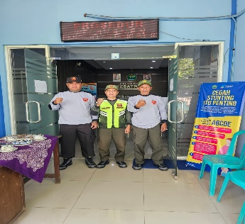 | 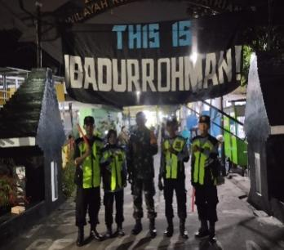 | 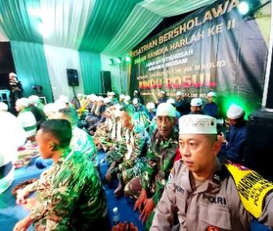
 | 1-3-2024 | 2-3-2024 (RW. 08) | RW 08
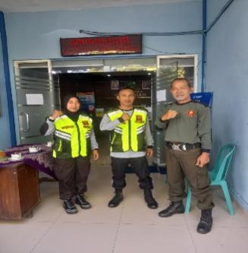 | 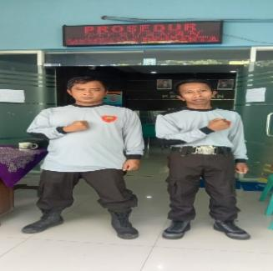 | 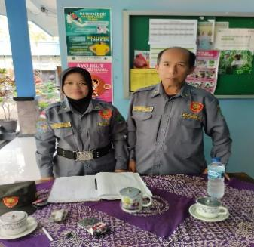 | 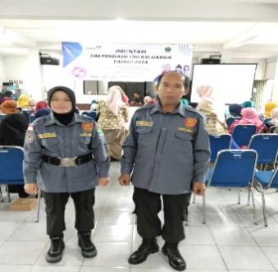
4-3 -2024 | 5-3-2024 | 7-3-2024 | Aula Kelurahan
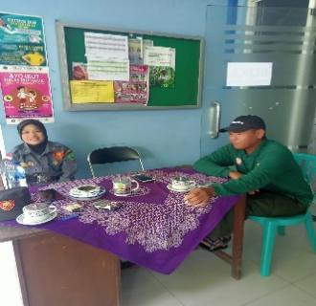 | 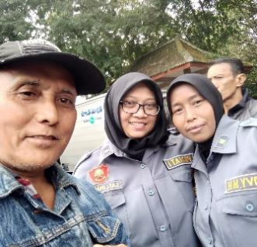 | 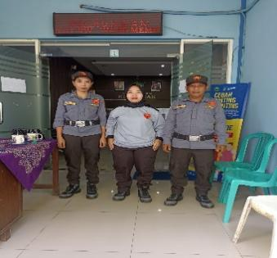 | 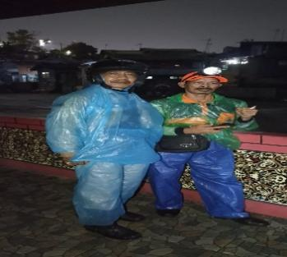
7-3-2024 | 7-3-2024 | 8-3-2024 | BPBD  (9-3-2024 )
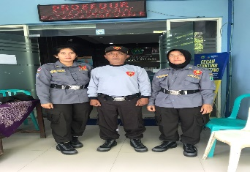 | 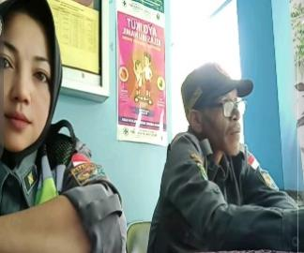 | 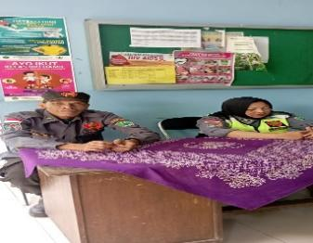 | 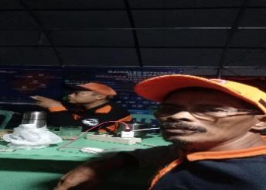
13-3-2024 | 14-3-2024 | 14-3-2024 | BPBD  14-3-2024
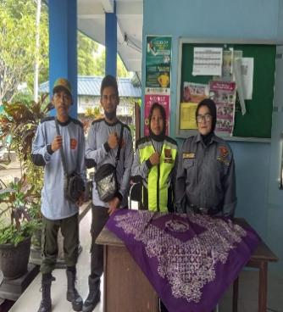 | 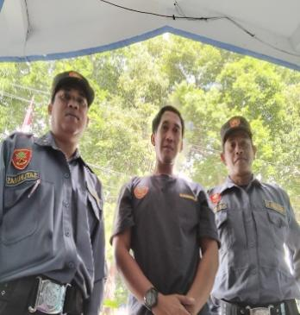 | 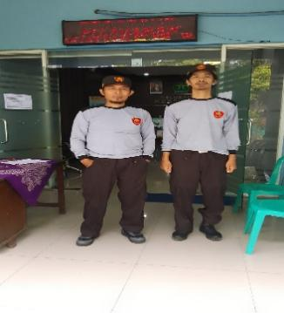 | 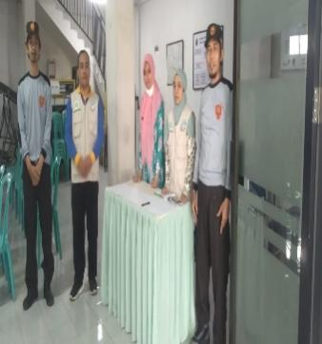
15-3-2024 | 18-3-2024 | 21-3-2024 | 21-3-2024
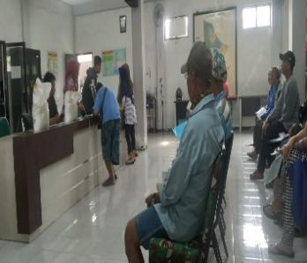 | 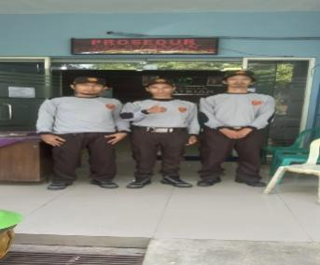 | 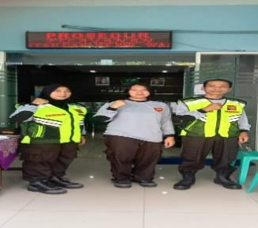 | 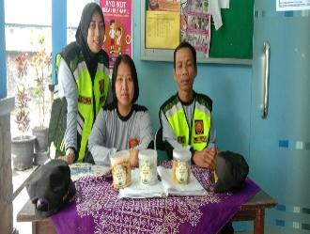
21-3-2024 | 21-3-2024 | 23-3-2024 | 23-3-2024
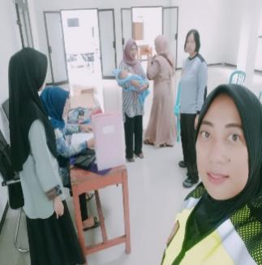 | 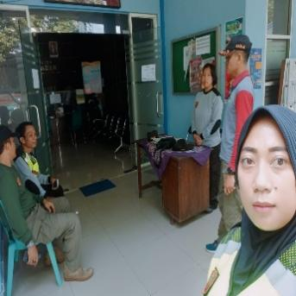 | 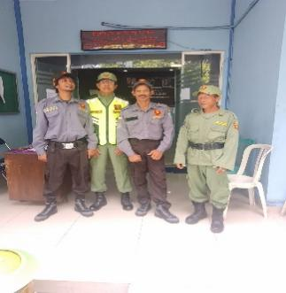 | 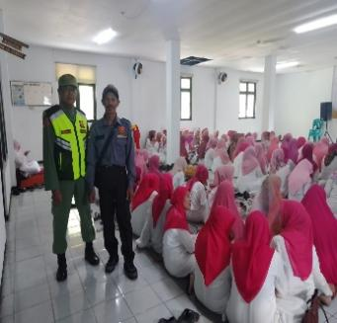
POSYANDU  21-3-2024 | Kunjungan Satpol  21-3-2024 | 25-3-2024 | Kegiatan PKK  25-3-2024
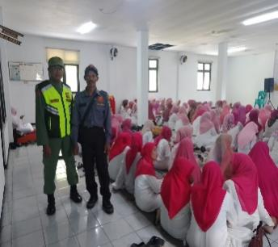 | 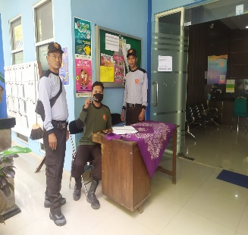
Kegiatan PKK  25-3-2024 | 26-3-2024

