DOKUMENTASI PENYALURAN BANTUAN SOSIAL KRS DISPANGTAN

KELURAHAN ARJOSARI KECAMATAN BLIMBING KOTA MALANG

TANGGAL 5 DESEMBER 2023

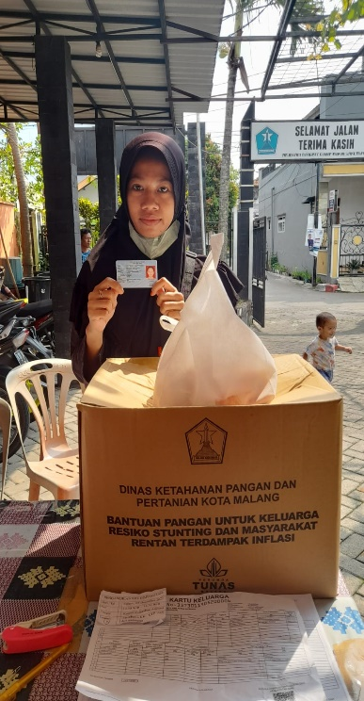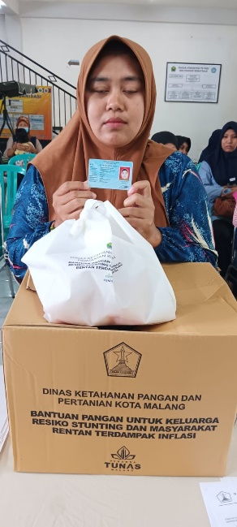

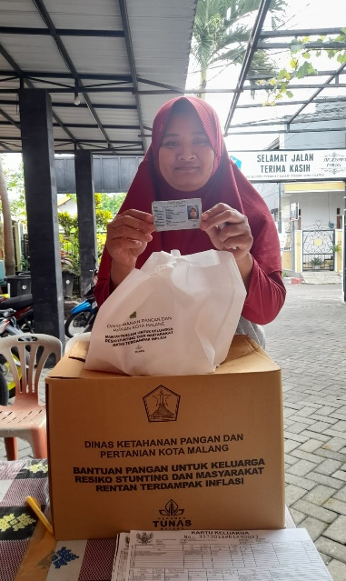

REKAPITULASI BANTUAN SOSIAL KELUARGA RESIKO STANTING ( KRS ) DISPANGTAN

BAGI WARGA MASYARAKAT KELURAHAN ARJOSARI

Selasa, 5 Desember 2023

|  |  |  |  |
| --- | --- | --- | --- |
| NO. | BULAN | JUMLAH WARGA YANG MENERIMA BANTUAN | KETERANGAN |
| 1. | NOVEMBER | 16 Orang | Diambil tepat waktu |