DOKUMENTASI PIKET JAGA KELURAHAN KESATRIAN
BULAN MARET 2025

NO. | PETUGAS PIKET | TANGGAL | FOTO | KET
1. | - KASTOWO AJI  - ADITYA MP  - FEBRY PRASETYO | 03-03-2025 | 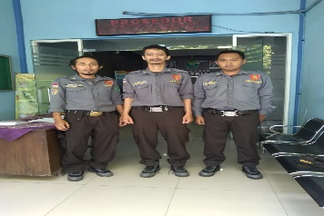
2. | - AHMAD SLAMET  - AGUS APIT S  - ARI PRABOWO | 04-03-2025 | 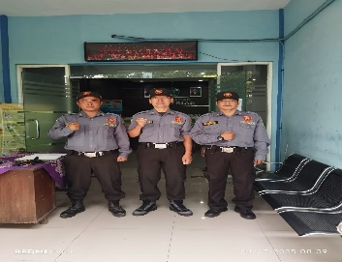
 |  |  | 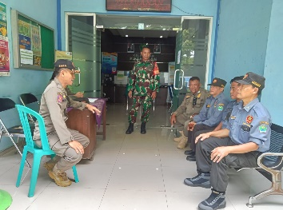
3. | - SAMI RAHAYU  - SUYONO HADI S  - DJOKO SUBEKTI | 05-03-2025 | 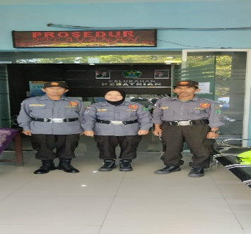
4. | - ELIK SUKARJONO  - M TAUFIK  - SAMSUL | 06-03-2025 | 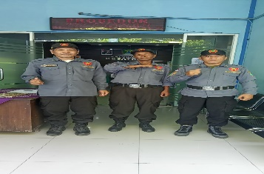
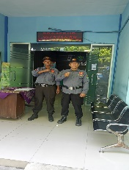
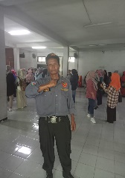

5. | - RIO CHOIRUL  - DANANG WIDODO  - YUDI GUNAWAN | 07-03-2025 | 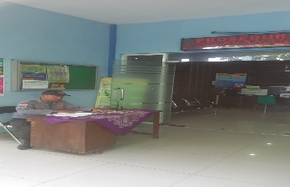
 |  |  | 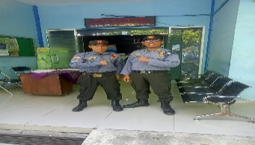
6. | - SUTIKNO H  - ANDIK SETIAWAN  - ZAENAL ARIFIN | 10-03-2025 | 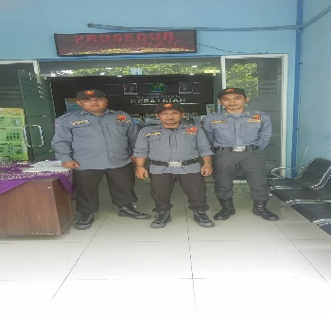
7. | - ANDIK AFIANTO  - MARUDUR  - TYAS RENA T | 11-03-2025 | 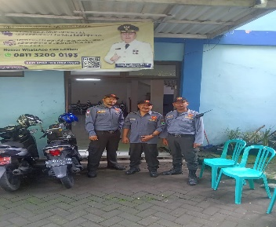
 |  |  | 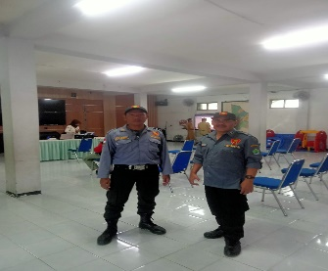
 |  |  | 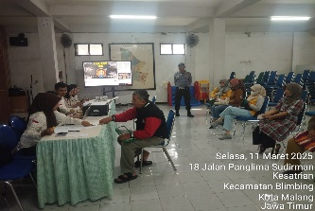
8. | - CHUSNUL  HIDAYATULLOH  - YOFI ANDRIANI  - FEBRI ANITA | 12-03-2025 | 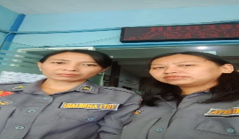
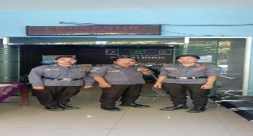

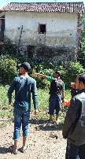
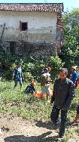
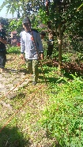

6. | - GALANG RIZKI P  - AHMAD SLAMET  - CHUSNUL CHOTIMAH | 13-03-2025 | 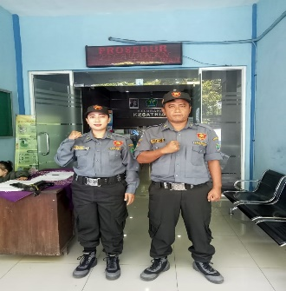
 |  |  | 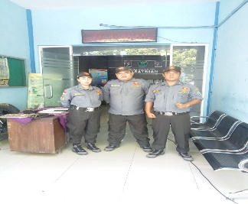
7. | - ARIEF SUHARTONO  - AKWAN  - SUNARMI | 14-03-2025 | 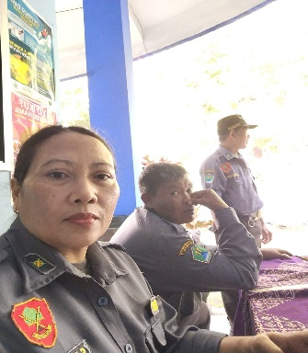
 |  |  | 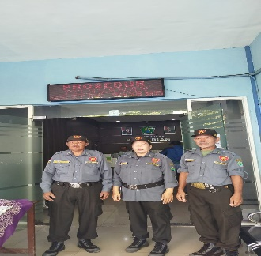
8. | - SUKATI  - MYRZANUR FITRIA A  - M. YUSSAK | 17-03-2025 | 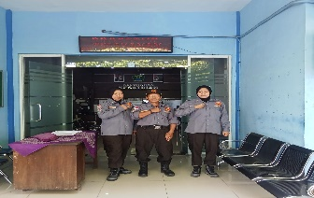  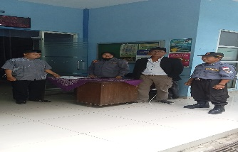
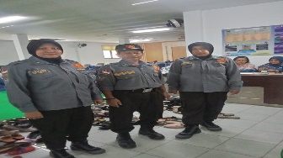
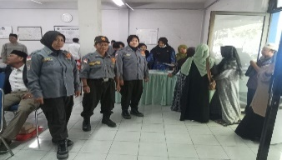
9. | - TEGUH SETIAWAN  - FIFIN YUNIARTA P  - CHOLILLAH | 18-03-2025 | 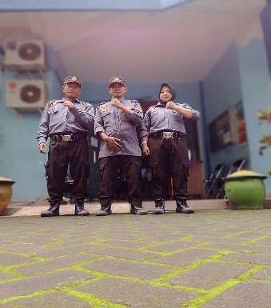
 |  |  | 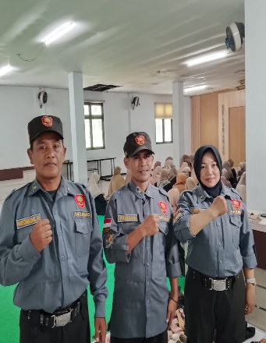
10. | - MUSTAKIM HUDA  - AGUS SUSANTO  - SRI MUDJIANAH | 19-03-2025 | 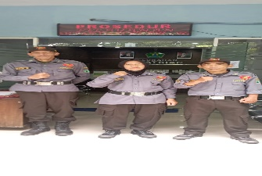
 |  |  | 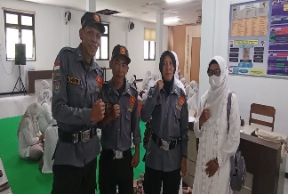
11. | - SODIKIN  - DJANWAR P  - SATRIYO WIBOWO | 20-03-2025 | 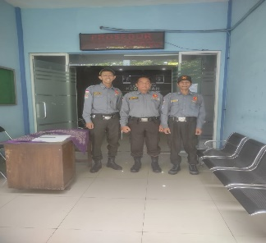
12. | - ABD MUNI  - ACHMAD ZAINI  - YUDHA SANJAYA | 21-03-2025 | 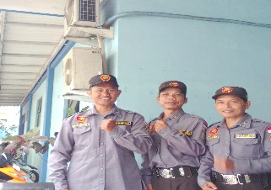
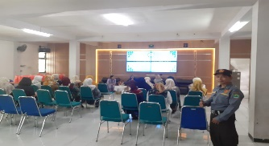

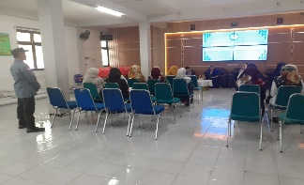

13. | - BUDI SANTOSO  - SYAHRANI  - PARYADI | 24-03-2025 | 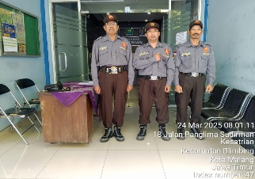
14. | - AGUS SUYONO  - SUMANTRI  - CHUSNUL CHOTIMAH | 25-03-2025 | 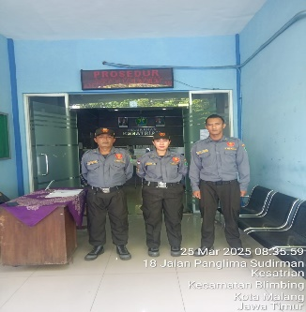
15 | - KHOIRUL ANSORI  - ABDUL SYUKUR ARIF  - SUKATI | 26-03-2025 | 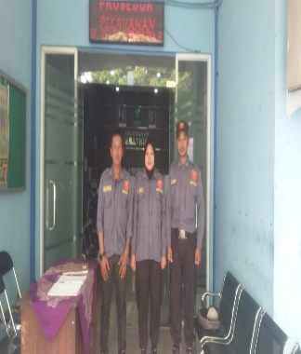
16 | - ARIEF SUHARTONO  - SUNARMI  - MYRZANUR FITRIA  AGUSTIN | 27-03-2025 | 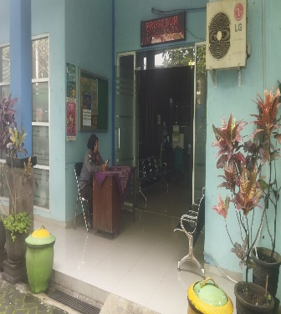
 |  |  | 